Executive Summary
This report is providing an analysis on a self-encrypted hard drive device manufactured by syba. The intent of the investigation is to apply as many digital forensics principals as possible. Methods of analysis are examination of the documentation provided by the manufacturer, the use of a logical analyzer and software followed by a file comparison procedure.
Detailed findings can be found further in the body of the text. Findings confirmed the already known facts that AES is only susceptible by brute force and side channel attacks. During the investigative process a theory of commonality, explained in detail further in the text, it is either highly unlikely or impossible to find a common property with the passkey designated by the user and the key used by the control chip in the encryption device.
This report concludes it’s necessary to further investigate the properties of a self-encrypting hard drive enclosure—possibly with more resources.
Recommendations are as follows:
- Advance the project up to a team with more resources and experience.
- Draft and execute a policy disallowing the use of SEDs.
- As it currently understood with this particular device, brute force the SED in order to gain access
Limitations of the project came inherently with it as this was a part-time enterprise. Each member had to compartmentalize their time in-order to focus on this project at sporadic time. Secondly, another limitation was the team’s lack of experience with an SED, having to essentially, make it up as it went along.

Note: Below is an excerpt from the full report. What is to follow only documents the procedure looking for commonality in the key generation of the Self Encrypting Device’s control chip.
(This section was written by Alex Andrews , a senior in the Digital Forensics class – CIT 420 at Indiana University Purdue University at Indianapolis)
There have been assumptions made that with the controller chip of the self-encrypting device, the brains of the encryption process, only uses a static key – unchanging key. Specifically it was brought up in conversation at the most recent Bsides Indy (http://bsidesindy2017.busyconf.com/schedule) , a local Indiana hacker convention that such a mechanism was in place. Why is this significant? Any sort of commonality that can be found in a device or mechanism of encryption is just one step closer to find an unknown secret.
So, with that in mind, the team used Kali Linux, since it includes tools readily available to handle this type of job. We started by creating a file that we knew the contents of. This is the part of deduction, one must start with something that is known. Remember in math class solving for an unknown variable? In that equation, there was always something known. The team created a file where we both knew the plaintext and cipher text to analyze any differences.
The file created was full of the letter “A”. This way it would be recognizable in either clear text or another recognizable format. Shown below in Figure 13.
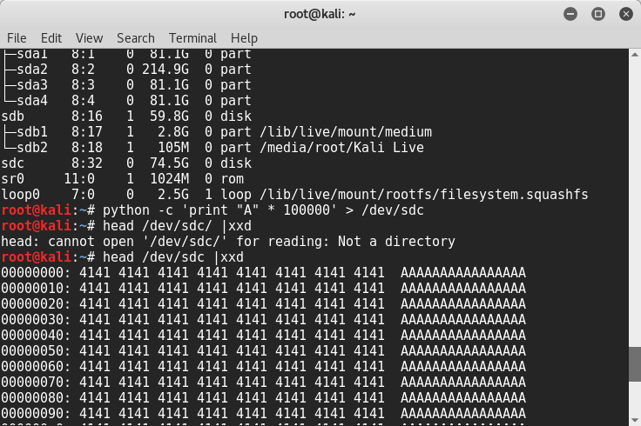
Figure 1: Plaintext A = cipher text 41

There’s actually quite a lot to see in this screenshot. The ‘41’ represents ‘A’ in hexadecimal. “sdc” is the hard drive that we are examining. The command “head /dev/sdc |xxd” is a means of doing an examination of what’s on ‘sdc’. The command further up, “python -c ‘print “A” * 100000’ > /dev/sdc” is the command that creates a file with 100k of “A”s that is sent to the hard drive.(sdc). Shown in Figure 14 below.
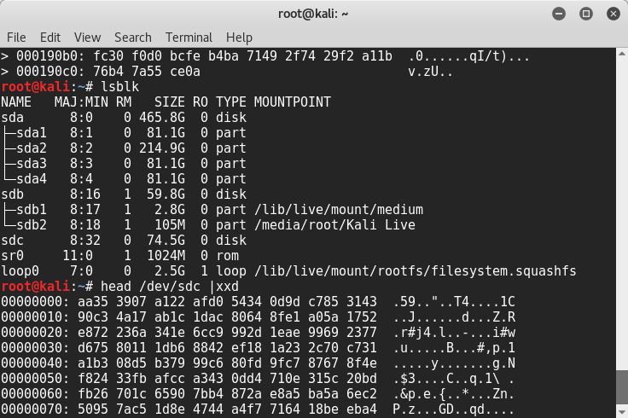
Figure 2: using head /dev/sdc |xxd command in Kali Linux

Now with the same file outside of the encryption enclosure, the same command is used to examine the file. (see figure 15) It looks weird doesn’t it? Doesn’t make sense. That’s because it’s encrypted, making it illegible.
We then create a file “password_2” (back with the enclosure on) with the same command as before. And then examine it outside the encryption enclosure. Just a quick glance, you can tell it’s different than the first file.
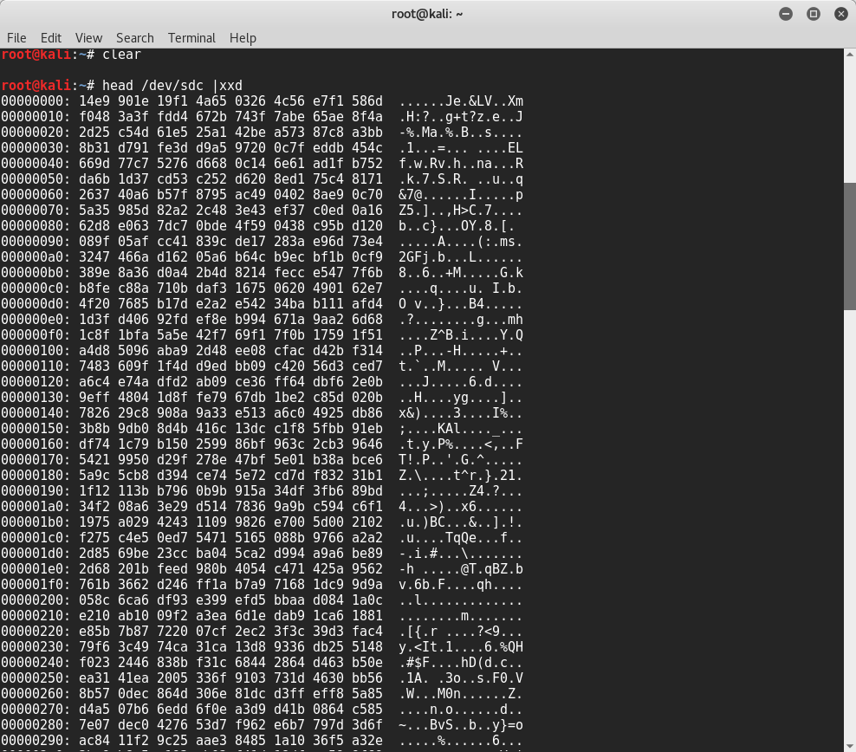
Figure 3: encrypted file on drive outside of SED enclosure
But there is a means to make sure the two files are different.
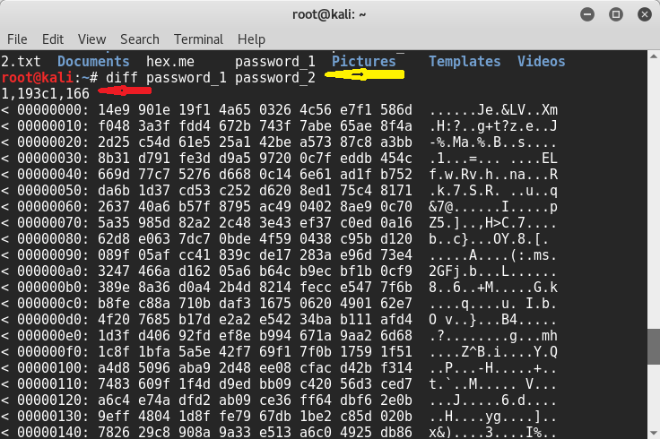
Figure 4: Using Linux diff command

If you’ll look at the yellow arrow, (see Figure 16) this command will make a comparison of both files. This shows the use of the Linux diff command. This command shows the difference between two files. The text below marked with a red arrow: “1,193c1,166” tells us there is indeed a big difference between the two files. What it means is that “1,193” lines 1 through 193 of the first file(password_1) are different that lines 1 through 166 of the second file. The comma represents a “through”. So ultimately, this proves the original hypothesis is wrong. There is not a static key. If there were, the files would be the same, since their contents are the same as well.
Now, with all that said, what if the random key that was being generated were dependent upon the passkey given?
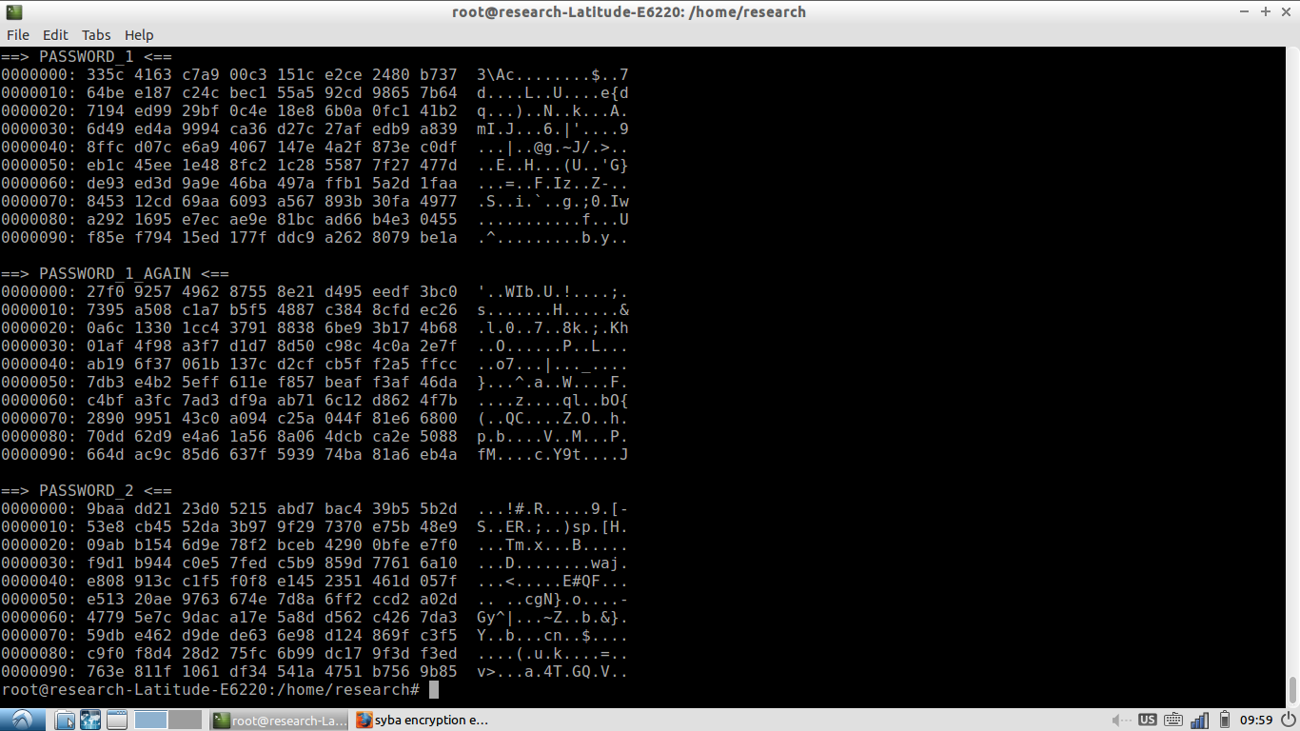
Figure 5: Different generations of a random key

If you’ll look above,(see Figure 17) courtesy of Rush Vyas, research assistant at Indiana University Purdue University at Indianapolis, you’ll see a screenshot of three different iterations of the process. First one was a passkey of “1”, the second with “2” and the third Rush went back to “1” to see if they encryption were the same or different. It appears to be different. That means the key within the control chip is generated each and every time randomly no matter the passkey given. Always looking for the commonality!

